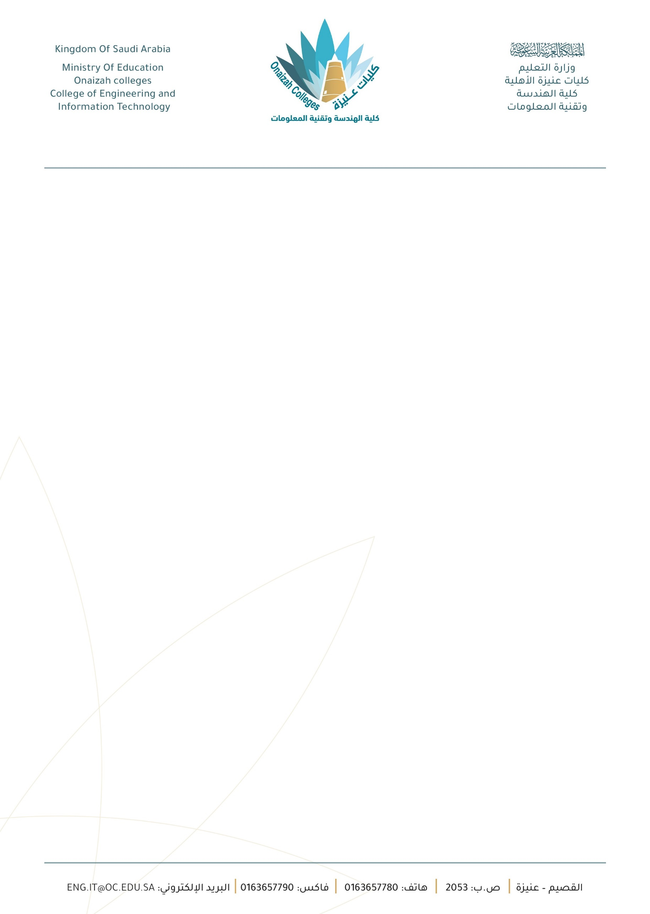

**Onaizah Colleges**

**Colleges of Engineering and Information Technology**

**SUMMER TRAINING REPORT** (Course code)

|  |  |
| --- | --- |
| **Student’s Name:** |  |
| **Student’s ID** |  |
| **Department:** |  |
| **Internal Supervisor:** |  |
| **External Supervisor’s Name:** |  |
| **Training Organization:** |  |
| **Training Duration:** |  |

**Year/ Semester:**

|  |
| --- |
| **Table of Contents:**  **Subject Page** |
| Table of Contents |
| List of Figures |
| List of Tables |
| Declaration |
| Abstract (Training Summary): |
| Chapter 1: Introduction of the Training Organization |
| Chapter 2: Training Assignments and Responsibilities |
| Chapter 3: Learned Skills |
| Chapter 4: Training Benefits and Outcomes |
| Chapter 5: Conclusion and Recommendations for Improvement of Summer Training |
| References |
| Appendix (brochures, maps, drawings, handouts,  Annual Reports, Certificate etc.) |

**Student Declaration**

This Training Report is submitted to College of Engineering and Information Technology at Onaizah Colleges, in partial fulfillment of the requirements of a Bachelor's degree in**__________________________**.

I declare that this Training Report is prepared by me and the views expressed herein are solely mine. They do not necessarily reflect the policies of the Training Organization where I worked as a Trainee.

Student's Name: ………………………Student No: ………………………

Student's Signatures: ………………………….....................................

Date of Declaration: ……………………........……........…...................

**Abstract (Training Summary**)

   (Maximum 150 words)

**Pages 1 through the last page include:**

## <Note: Refer to the General Guidelines for Report Writing at the end of the SAMPLE Report>

**Chapter 1: Introduction of the Training Organization**

This Chapter should introduce the Organization. It may include information such as:

1. The Organization’s Name, Location, Nature of Business etc.
2. The Organization’s Administrative Structure
3. Job description of various employees within the Organization
4. Approximate number of employees

**Chapter 2: Training Responsibilities and Assignments**.

This Chapter should describe in detail the objectives of the training, the training schedule, and what responsibilities and assignments were given to the Trainee to meet the desired objectives.

**Chapter 3: Learned Skills**.

In this Chapter the student Trainee can highlight all the things he learned as part of this training, the students can include things such as teamwork, inter-personnel skills, business relationships etc.

With reference to their particular assignments, the students can include a section on how to relate real life engineering and technical problems to the theoretical concepts introduced to them in class rooms. They can also discuss problems and difficulties faced in carrying out the assignments.

**Chapter 4: Training Benefits and Outcomes**

This chapter should summarize the main Engineering and Technical skills learned during the training. The Chapter should also highlight the benefits of the received training and how it would help the trainee student in the development of his professional career.

**Chapter 5: Conclusion and Recommendations for Improvement of Summer Training**

This Chapter will include general recommendations for both the College and the Training Organization about improving the quality of the Training.

It can also include recommendations for future trainees regarding the suitability of the Organization to spend time as a Trainee.

This chapter could discuss:

1. What was learned, or
2. The main conclusion and main personal outcomes from the Summer Training.
3. The student view of, how this Summer Training may improve his professionalism.

**References**:

Document any citation to any learned or used computer program, referred books/articles in preparation of this report by consecutive Arabic numerals. List all these references at the end of the report as follows:

1. *For books*

Harrow, R. (2005), *No Place to Hide*, Simon & Schuster, New York.

1. *For Journal papers*

Capizzi, M.T. and Ferguson, R. (2005), "Loyalty trends for the twenty-first century", *Journal of Consumer Marketing*, Vol. 22 No. 2, pp. 72-80.

1. *For websites*

Castle, B. (2005), "Introduction to web services for remote portlets", available at: <http://www-128.ibm.com/developerworks/library/ws-wsrp/> (accessed 12

November 2007).

1. *For computer programs*

Computers and Structures Inc. (2009), ETABS v 9.5.0 – Integrated analysis, design and drafting of building systems, CA.

**General Guidelines for Report Writing:**

* Students should type their reports with font of **Time New Roman**, size **14 point** on **A4** sheets on one side, and with spacing of **1.5** for the main text.
* Students should use size of **16 points** for the main headings.
* Minimum number of pages **25**.
* The pages should be consecutively numbered.
* Margins should be respected for all pages
* Students should use their own language as much as possible.
* Students should report the references they refer to in the text of their report with consecutive numerical numbering. Copying from manuals or books is not acceptable.
* Figures, Tables and Appendices should be numbered with captions, and they should be referred to in the text.
* Spell check before submitting the report.
* Avoid repetition.
* The student must avoid plagiarism and the report will be rejected in case of citation ratio is more than (25%)
* The student may include brochures, maps, drawings, handouts, Certificate as needed at the end of his report as appendices.